Local Researcher - Application Form

Full Name
Gender
Date of birth
Nationality
Contact Number
Email
Languages | English: 1) some 2) good 3) excellent  French: 1) some 2) good 3) excellent  Other: ___________1) some 2) good 3) excellent
How long have you been living and/or working in Ras Beirut?
List relevant experience that makes you a suitable candidate for this project (this can be your education background, your previous or current work, a hobby or community leadership role) | (Optional: please provide degrees, certificates,…)  (Optional: Contacts of a reference who you’ve worked with)
How did you find out about this project?

Please explain why you are interested in taking part in this project:
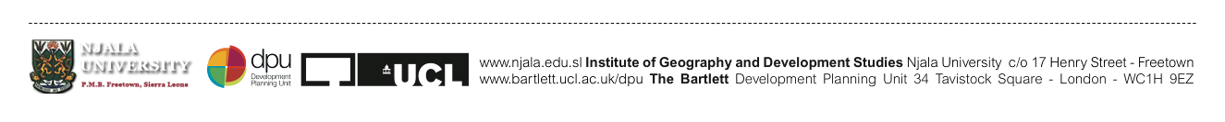
___________________________________________________________________________________________________________________________________________________________________________________________________________________________________________________________________________________________________________________________________________________________________________________________________________________________________________________________________________________________________________________________________________________________________________________________________________________________________________________________________________________________________________________________________________________________________________________________________________________________________________________________________________________________________________________________________________________________________________________________________________________________________________________________________

If accepted, I confirm that I have read and understood what is required and I will be available to attend:
- Interviews between 5 and 9 April 2021.
- induction and trainings on 14, 16 and 19 April 2021.
- On the 14th , 16th and 19th of April: 3 days of trainings/consultations in person or partially online; allocated time to conduct up to 100 surveys during the months of April, May and June 2021 (specific dates are subject to change depending on lockdown restrictions but the time commitment remains the same)
- Complete quality DCE worker and employer surveys efficiently (time varies according to personal skill and experience)

Please note that all dates are subject to change according to Lebanon’s Coronavirus Lockdown.

Signature

Date

Please send a completed application form by email to Diala Makki at dialamakki1@gmail.com and Mayssa Jallad mayssajallad@gmail.com or by WhatsApp at +961 81 42 37 10 (Please note that this number will only be used for Whatsapp). Please include the subject title: Local Researcher Application_your full name.

